1:

Madam President, it would really be very difficult to imagine a debate which is more in accordance with Rule 50 of our Rules of Procedure. This debate is topical, exceptionally important and urgent. We therefore believe that the agenda should be amended to include it. Madam President, until now we believed that the European Union was, according to the Treaty of Rome and the Treaty of Paris founding the European Communities, and subsequently the Union, an association of free, independent, sovereign states. Even though many developments cast doubt on this, we did believe, in spite of everything, that this was

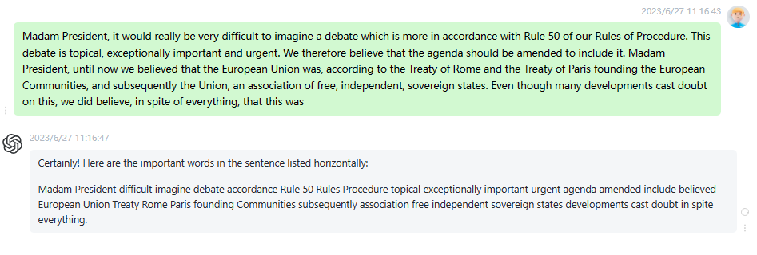

时延0.15s

2:

Well, patently, if we do open this debate today, Madam President, as you are requesting and as the Conference of Presidents is requesting, on the basis of Rule 50, we shall then be opening up a fearsome breach in the principle of the freedom and sovereignty of the national states and the free constitution of democratically elected governments, enabling some other majority in this Parliament, at some future time, to claim the right to interfere in the formation of a government even though it has assumed power on the basis of free, regular, peaceful and democratic elections within a Member

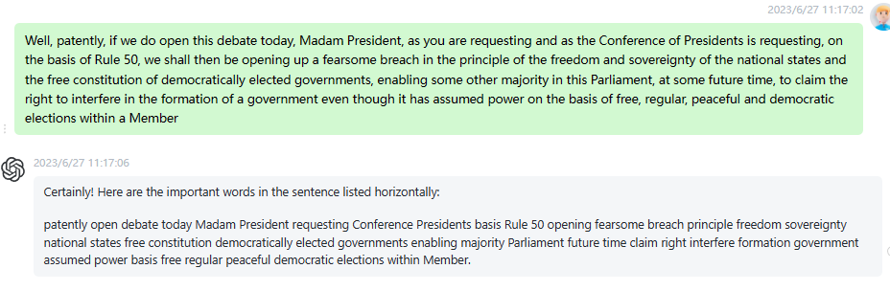

时延0.2s

3:

If you ratify this development, then you are ratifying the development of the Union into a body which violates the sovereignty and the freedom of the Member States, and we should then have no option but to withdraw from such a Union. This debate is therefore added at the top of the order of business. The next item is the debate on topical and urgent subjects of major importance. The next item is the debate on the talks in Austria on forming a government. Austrian candidates for posts in international organisations will not have the support of these fourteen countries.

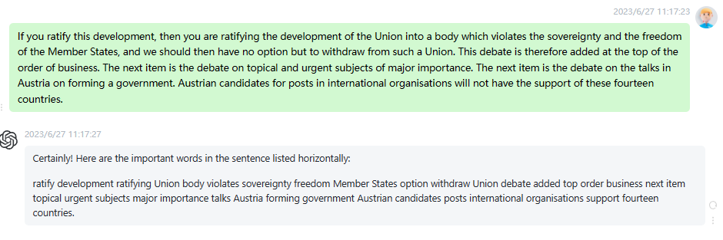

时延0.2s

4:

I think that over the last few days, the reasons which have led the fourteen states supporting this statement to adopt it have become clear. Basically, the view these states share of the political situation in Austria led them to conclude that the possible inclusion in the Austrian Government of a party such as the Freedom Party could bring about a change in respect for the common values which the Member States of the European Union are committed to safeguarding. We are all aware of the public statements made by Haider and of some of the ideas on specific policies

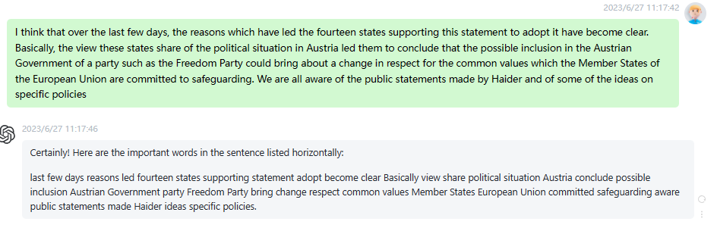

时延0.2s

5:

It could be said that the present situation is a result of the people of Austria exercising their freedom of expression, which must be respected, and that any stand on this subject might be tantamount to interference. First of all, Madam President, ladies and gentlemen, no one is threatening the existence of a democratic government in Austria or questioning the electoral reality behind the results of the recent elections. What we regret, and take issue with, is the fact that the solution opted for gives a share of political power in that country to a party whose leaders have not

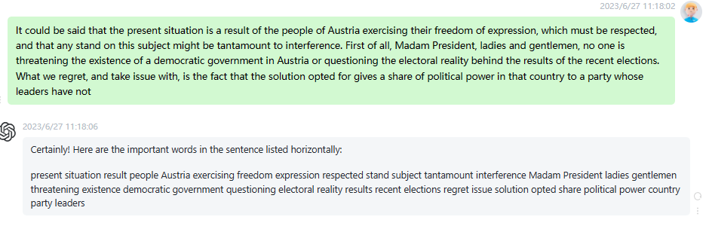

时延0.2s

6:

Let me repeat that point, this applies to Austria today and it would apply tomorrow to any Member State of the European Union. On the other hand, as we all know, human rights, fundamental rights issues, the great principles of democracy and of the rule of law, the rules for protecting minorities and combating racism, xenophobia and intolerance are no longer issues to be discussed purely within a country. All the more so when that country belongs to a community of states for which these concerns represent the very heart of its project for civilisation. The Europe that we want

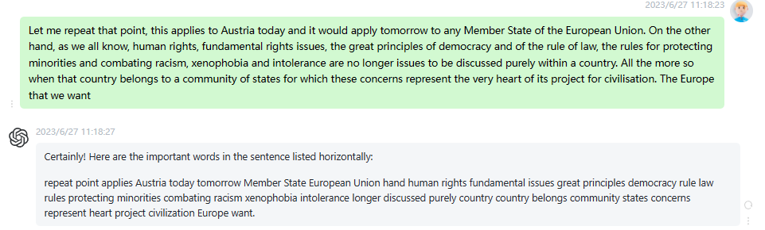

时延0.2s

7:

The Commission, like Parliament, is a supranational institution of the Union, and for that very reason it has no bilateral diplomatic relations with the Member States. Let us not forget that the Treaty of Rome does not contain any clause providing for the voluntary withdrawal or the expulsion of a Member State. This is because the logic, the very assumption underlying the extraordinary achievement that is the European Union is that when each State becomes a member of the Union, it accepts its fundamental principles completely and forever. Moreover, the Treaties set out precise mechanisms for ensuring that these principles

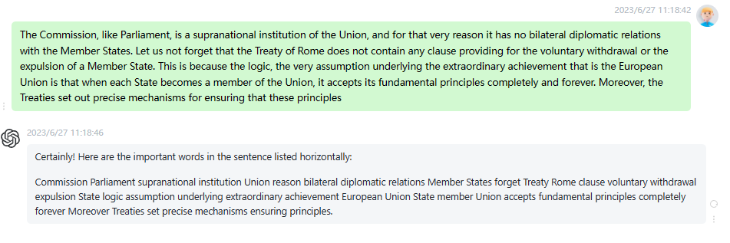

时延0.2s

8:

Ladies and gentlemen, when one of its members is in difficulty, the whole Union is in difficulty. The duty of a strong supranational institution is not to isolate one of its members, but instead to permanently bind it to its deep seated values. The Commission will do its utmost to ensure that this is done. On the other hand, it goes without saying that the Commission will continue to keep a close eye on events in Austria. Indeed, the European Union would not survive without the principles of freedom, democracy and respect for human rights. These are the foundations of

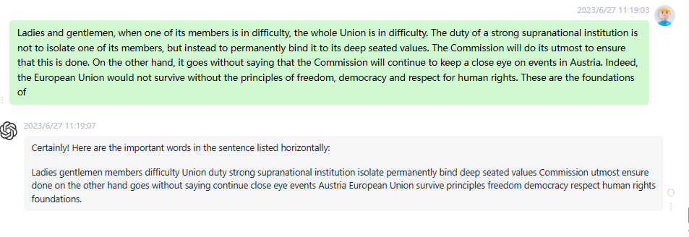

时延0.2s

9:

These principles form an integral part of the rule of law, and the Commission, which is the guarantor of that rule of law, will be relentless in upholding them. We will bear down heavily on even the slightest breach of the rights of individuals or of any minority. Europe, as a Member of Parliament from one of the applicant countries said to me, is a union of minorities. Founded over 900 years ago, Bologna University, my alma mater, is the oldest university in the world. On the walls of one of its most beautiful halls you can still see the

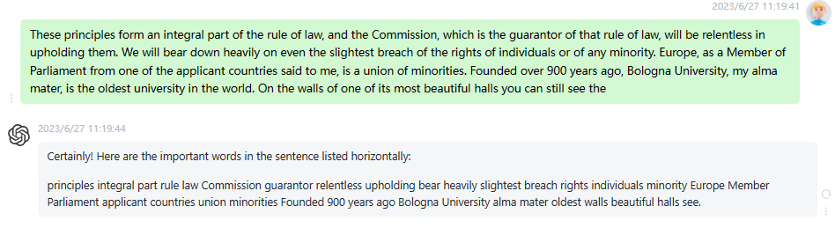

时延0.15s

10:

Europe already existed then: an area whose intellectual confines were unaffected by the frontiers and limits of the politics of the day; a community of shared values, ideals and knowledge. However, the fabric of European history has not only been woven with cultural interchange, the expansion of knowledge and the sharing of a robust core of common values. Alongside the university coats of arms, there are war memorials in every small village or town in Europe, which bear witness to the tragedies of our continent. European history has been punctuated over the centuries by an unremitting sequence of wars and



时延0.15s